Technical Design Document
Student Administration System

For UCI Java Programming I (Winter 2015)
Team A

Tina Fredericks, Perry On, Michael Morodomi, and Darron Fuller

Purpose
The purpose of this Technical Design Document is to provide the details for the implementation of a Student Course Management and Registration System like one that may be used by a college or university (See Figure 1. Use Case Diagram for Student Registration System). The rationale for implementing such a system is to facilitate better course management by registrars and ease of access for students to select, register, and manage their curriculum throughout the course registration process.

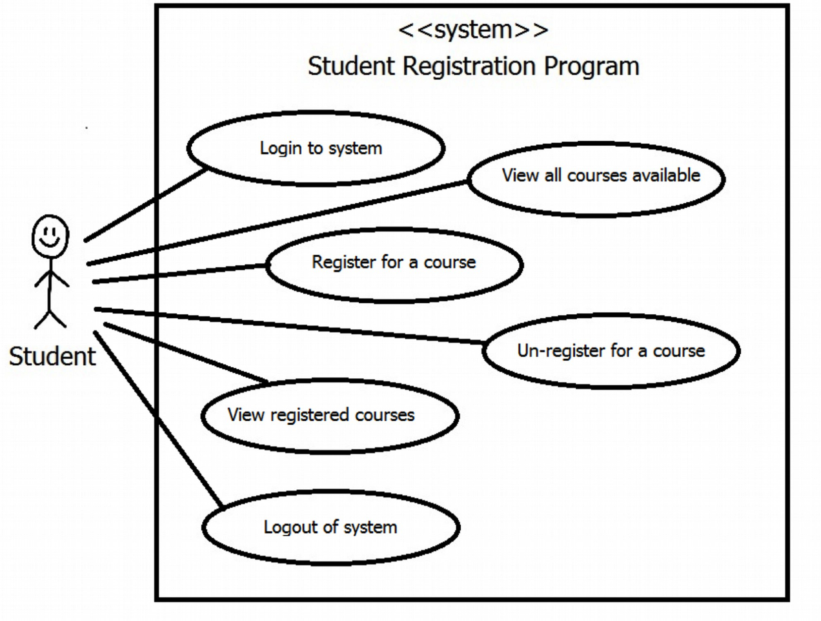
Figure 1. Use Case Diagram for Student Registration System

Entity Overview
The following describes the objects that are used in the design of the Student Course Registration application:
- Course object represents a course available for selection in a registration system. The Course object supports tracking information about the course description, dates and enrollment count and capacity. Constructor methods and methods for getting and setting course object variables will be implemented.
- Student object represents a student that is currently enrolled and eligible for registering for courses in the system. The Student object supports tracking information about a student including the student’s unique ID, password for system access, name, and list of their registered courses. Constructor methods and methods for setting and getting student object variables and registering for courses will be implemented.
- Registration object represents a single Student/Course registration instance.

Activity Diagram
Figure 2. Activity Diagram for Student Registration System

Entity Design Details
The following describes the objects that are used in the design of the Student Course Registration application:

RegSys CLASS

Variables
private static ArrayList<Course> courseList
private static ArrayList<Student> studentList
private static Scanner userInput
private static Student regStudent
private static RegSys regSys
private static final String courseFileName = "CourseDatabase.csv"
private static final String studentFileName = "StudentDatabase.csv"
private static final SimpleDateFormat formatter = new SimpleDateFormat(Course.COURSE_DATE_FORMAT);
private static final String HEADER_SPACING = "\n"
private static final String COURSE_HEADER = HEADER_SPACING + String.format("%-6s%-8s%-12s%-12s%-30s%-5s%-5s%s", "ID", "NAME","START DATE","END DATE","DESCRIPTION","ENR","CAP","STATUS") + "\n"
private static final String SUCCESSFULLY_SAVED_TO_DATABASE = "(Saved to database file.)"

Methods

public static void | main(String[] args)  Main function contains all program logic to support the activity flow as described in Figure 2. Activity Diagram for Student Registration System. Use the RegSys class methods to authenticate student, display menus, and perform all required functions.  The following is a summary overview of the general program operation:  1. Create and Course Database File (populated), Student File (populated w/o course registrations) in format according to the following file format specifications:  Course database:  <courseID>,<name>,<dateStart>,<dateEnd>,<summary>,<enrollLimit>,<studentCount>  Note: Dates are in MM/DD/YYYY format.  Student database:  <studentID>,<firstName>,<lastName>,<password>,(optional: <courseID1>, <courseID2>,etc)  Place botht he Course and Student Database files in the root directory of the application.  2. On start, Application reads the Course File and Student File into ArrayLists. Assume these files are well-formed and without issue;  3. Authenticate from the ArrayList<Student>;  4. Upon the event of a student registering for a course to a course, immediately update the ArrayLists for Courses and Students and rewrite the entire Course Database File to update student enrollment counts and the Student Database File from the contents of the in-memory ArrayLists;  5. Exit the system and Restart returns back to Step #1 where the Course and Student Database files will be reloaded including all updates during the previous session.
public void | displayAllCourses()  Lists all courses and course object details in alphabetical order by course name and indicate availability
public void | displayCoursesOfStudent()  List the courses in which a student is currently registered
public void | displayLogin()  Displays login prompt and gets user id and password as input.
public String | displayMenu()  Displays system main menu and gets console input for user’s menu selection.
public Course | getCourseById(String courseID)  Returns Course object for Course with identifier specified by the courseID parameter. Otherwise returns null if not found.
public String | getCourseIdInput(boolean isRegister)  Used to display and get user selection for Register or Unregister functions. Returns a String of the CourseID selected for registration/unregistration or “X” if the user cancelled the operation.
public boolean | isCourseDBLoaded()  Reads in the Course database (text/csv file) and loads it into Course ArrayList<Course> courseList. Returns TRUE if successful, otherwise returns FALSE.
public boolean | isDatabaseLoaded()  Returns TRUE if Student and Course Databases are loaded into ArrayList<Student> studentList and ArrayList<Course> courseList. Otherwise returns false.
public boolean | isStudentDBLoaded()  Reads in the Student database (text/csv file) and loads it into Student ArrayList<Student> studentList. Returns TRUE if successful, otherwise returns FALSE.
public Student | login(String studentID, String password)  Authenticates student and returns TRUE upon successful login, otherwise returns FALSE.
public boolean | refreshCourseDB()  Updates the coursedatabase.csv file with current contents of ArrayList<Course> courseList.
public boolean | refreshStudentDB()  Updates the studentdatabase.csv file with current contents of ArrayList<Student> studentList.
public boolean | register(String courseID)  Returns TRUE on successful registration, otherwise returns FALSE. Performs checks valid student ID (exists on studentList), valid course (exists on courseList) and open seats available (call course.openSeat() method), and duplicate registration (student/course combination exists on regList)  Displays error on failure of any of the above checks.
public boolean | unregister(String courseID)  Returns TRUE on successful registration otherwise returns FALSE. Checks if student is registered for course (student/course combination exists on regList) and display error if not registered

COURSE CLASS

Variables
private String courseID – unique ID for course
private String name – short name for the course (e.g., CMSC 412)
private Date dateStart
private Date dateEnd
private String description (e.g., Operating Systems)
private int enrollLimit
private int studentCount
protected static final String COURSE_DATE_FORMAT = "MM/dd/yyyy"
private SimpleDateFormat dateFormat = new SimpleDateFormat(COURSE_DATE_FORMAT)

Methods
public Course | Course()
Public Course | Course(String courseID,  String name,  Date dateStart,  Date dateEnd,  String description,  int enrollLimit,  int studentCount)  - Course ID – unique identification number for course.  - String name – concise name for the course  - Date start – start date in mm/dd/yyyy format for the course instance  - Date end – end date in mm/dd/yyyy for the course instance  - String descr – detailed description of the course  - int enrollLimit – number of students allowed to be simultaneously enrolled in the course  - int studentCount – current student count
public int | compareTo(Course c1)  Implemented to support Comparable interface. Equality is based on comparison of the this.name and c1.name.
public boolean | enrollment()  Process an enrollment. Returns True if space was available and enrollment was successful.
public String | getCourseID()
public String | getDescription()
public Date | getEnd()
public int | getEnrollLimit()
public String | getName()
Date | getStart()
public int | getStudentCount()
public boolean | openSeat()  Returns TRUE if a seat is available for registration
public void | setCourseID(String courseID)
public void | setDescription(String description)
public void | setEnd(Date date)
public void | setEnrollLimit(int enrollLimit)
public void | setName(String name)
public void | setStart(Date date)
public void | setStudentCount(int studentCount)
public String | toString()  Return the details of the course formatted for listing output to console
public boolean | unenrollment()  Process an unenrollment. Returns True if unenrollment was successful (i.e., course enrollments existed and not at zero)

Model Diagram

STUDENT CLASS

Variables
- String studentID
- String firstName
- String lastName
- String password
- ArrayList<String> regCourses

Methods
public Student | Student()
public Student | Student(String sID, String fName, String lName, String pw)
public String | getFirstName()
public String | getID()
public String | getLastName()
public String | getPassword()
public ArrayList<String> | getRegCourses()  Returns an ArrayList<String> containing all the Course ID’s of the courses in which the student is registered.
public boolean | isRegistered(String cID)  Returns true if student is already enrolled in course. Otherwise, returns false.
public boolean | register(String cID)  Register student for course indicated by courseID. Returns true on successful registration (i.e., non-blank course ID supplied). Otherwise returns False.
public boolean | setFirstName(String fName)  Returns true if student has successfully been assigned first name. Returns false on blank fName.
public boolean | setID(String sID)  Returns true if student has successfully been assigned student ID. Returns false on blank sID.
public boolean | setLastName(String lName)  Returns true if student has successfully been assigned last name. Returns false on blank lName.
public boolean | setPassword(String pw)  Returns true if student has successfully set password. Returns false on if blank pw.
public String | toString()  Returns student details in a formatted string that can be used for display output to console.
public boolean | unregister(String cID)  Unregister student for course indicated by courseID. Returns false if blank cID.

User Interface Design

The Student Registration System will be implemented as a Command Line application with a text-based interface. The following diagrams are mockups of the User Interface for the Student Registration System:

Test Cases
The following are the set of Test Cases that will be used to assure the system is operating as expected as per the requirements specification:

Test 1. At login prompt, enter valid username and valid password. Expected Result: Student is presented with main menu.

Test 2. At login prompt, enter invalid username and valid password. Expected Result: "Invalid login" error message and return to login prompt.

Test 3. At login prompt, enter valid username and invalid password. Expected Result: "Invalid login" error message and return to login prompt.

Test 4. At login prompt, enter invalid username and invalid password. Expected Result: "Invalid login" error message and return to login prompt.

Test 5. At main menu, enter '1' (Displays All Courses). Expected Result: Display alphabetical list of courses that includes the course identification number, course dates, name, brief summary, the enrollment limit, and the number of students already enrolled. Display main menu.

Test 6. At main menu, enter '2' (Displays Enrolled Courses). Expected Result: Display courses that student is registered. Display main menu.

Test 7. At main menu, enter '3' (Register for Course). Expected Result: Display alphabetical list of courses that includes the course identification number, course dates, name, brief summary, the enrollment limit, and the number of students already enrolled. Prompt user to enter course# to register (Register Prompt).

Test 8. At main menu, enter '4' (Un-register a Course). Expected Result: Display courses that student is registered. Prompt user to enter course# to un-register (Un-register Prompt).

Test 9. At main menu, enter '5' (Logout). Expected Result: Log student out of system. Display login prompt.

Test 10. At main menu, enter invalid menu item. Expected Result: "Invalid menu item" error message and return to main menu.

Test 11. At Register Prompt, enter a course that does not exist. Expected Result: Display "course does not exist" error message. Display alphabetical list of courses that includes the course identification number, course dates, name, brief summary, the enrollment limit, and the number of students already enrolled. Prompt user to enter course# to register (Register Prompt).

Test 12. At Register Prompt, enter a course that does exist and that a student is already registered. Expected Result: Display "already enrolled in this course" error message. Display alphabetical list of courses that includes the course identification number, course dates, name, brief summary, the enrollment limit, and the number of students already enrolled. Prompt user to enter course# to register (Register Prompt).

Test 13. At Register Prompt, enter a course that does exist and that a student is not already registered and that is full. Expected Result: Display "this course is full" error message. Display alphabetical list of courses that includes the course identification number, course dates, name, brief summary, the enrollment limit, and the number of students already enrolled. Prompt user to enter course# to register (Register Prompt).

Test 14. At Register Prompt, enter a course that does exist and that a student is not already registered and that is not full. Expected Result: Add studentId and courseId to Registration text file. Display "successfully registered" message. Display main menu.

Test 15. At Un-register Prompt, enter an invalid course. Expected Result: Display "invalid course" error message. Display courses that student is registered. Prompt user to enter course# to un-register (Un-register Prompt).

Test 16. At Un-register Prompt, enter a course that student is not registered. Expected Result: Display "you are not registered to this course". Display courses that student is registered. Prompt user to enter course# to un-register (Un-register Prompt).

Test 17. At Un-register Prompt, enter a course that a student is registered. Expected Result: Remove studentId/courseId from Register text file. Display "successfully un-registered" message and display main menu.

